**Natufian Culture**

Q8

According to paragraph 4, which of the following may have helped push the Natufians toward farming as a way of life?

A. At the same time as the Natufian population was increasing, the climate was becoming less hospitable.

B. The development of sickles and other tools made it possible for Natufians to exploit new kinds of cereals.

C. The climate changed during the Natufian period and produced conditions favorable to growing cereals.

D. Increasing competition from neighboring populations may have forced Natufians to grow cereals more intensively.

我的答案 D  正确答案 A

这个题对应原文中” There were climate changes, of course, and growing aridity and rising population densities may have forced them to intensify the exploitation of cereals”, 提到了Climate changes和increasing population，对应A选项

D选项当时看到increasing population就选了，没有看到competition from neighboring populations，这个是原文中未提及的部分

Q10

Answer Choice:

A. The Natufians used tools to collect and process food, but their lack of containers suggests that they rarely had excess food to store.

B. Natufian culture developed somewhat differently in different regions, in part because of differences in the types and amount of food available from place to place.

C. The increase in salt in the Natufians’ diet suggests that meat was becoming harder to find, perhaps because of climate change.

D. Although their diet included meat from hunting, extensive evidence suggests that the Natufians consumed a lot of cereals and may even have been cultivating them.

E. The Natufians engaged in trade and lived in large camps in which they sometimes built permanent structures.

F. Natufian art, personal ornamentation, and burial sites suggest cultural changes involving an increasing sense of ethnic identity and perhaps an ancestor cult.

我的答案:ADF 正确答案:DEF

A选项中后半句rarely had excess food to store 为过度理解，原文中并未提及

B 选项未提及

C选项说反了，是decrease of salt说明了meat is hard to find, 而不是increase

D 选项是第一段的概括，提到了meat 和 cereals在人们饮食当中的关系

E选项是第二段的概括，提及了trade和定居建筑

F 选项是第三段的概括

总结：这篇文章其实说难不难说简单不简单，因为6选3的正确答案全都是一个段落的总结，但是前三个错误选项无疑让做题的同学起了疑心，因为很少出现前面三个选项连着不对的情况，进而选择A这种对一半的选项来给自己一个合理的解释

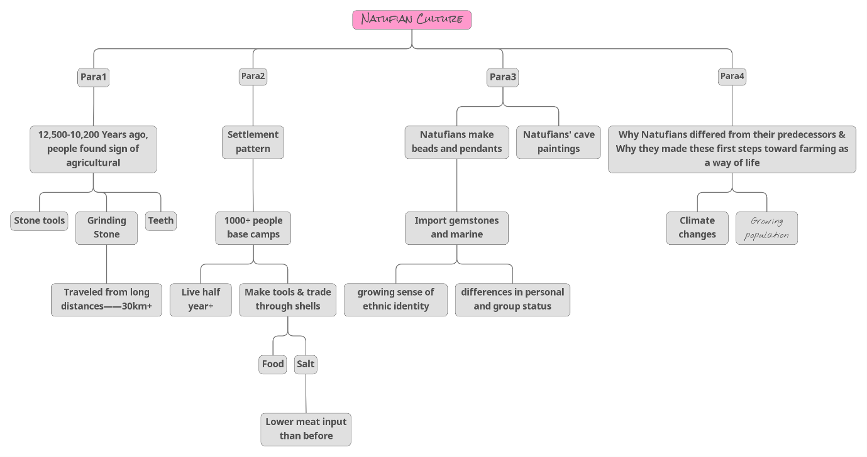

Stream Deposits

According to paragraph 1, all of the following are true of stream sorting EXCEPT:

A. Most of the particles in mountain streams pile up behind boulders and cobbles.

B. When particles of different sizes settle in a place, the smaller ones sit atop the larger ones.

C. There are generally more large particles upstream than downstream in a river.

D. In some situations, downstream particles are created from rocks that eroded as they traveled downstream.

我的答案 C  正确答案 A

C对应 “Many mountain streams are choked with boulders and cobbles, but far downstream, their deltas are composed mainly of fine silt and clay.”,不知道为啥当时读的时候看反了，导致以为是downstream更多大块

A 选项对应 “Many mountain streams are choked with boulders and cobbles”,正确

Why does the author ask the reader to **“Imagine a winding stream”**?

A. To explain how the presence of bars changes the speed and direction of water flow in a stream

B. To explain why bars are more common than alluvial fans or other types of sediment deposits

C. To illustrate the particular difficulties that commercial navigation faces on many rivers

D. To help explain how point bars are formed

我的答案 C  正确答案 D

“The water on the outside of the curve moves faster than the water on the inside.”是作者让读者想象winding stream的目的，用来解释bars是怎么形成的

The word “exploiting” in the passage is closest in meaning to

A. making use of

B. finding

C. destroying

D. looking for

我的答案 D  正确答案 A

竟然错了TOT，exploit的本意是发掘，发现，looking for也可以，但是文中指的是利用，就很烦